**Structure and Interactions of Glutamine**

Geometric optimization of glutamine molecule is performed with Gaussian and Gaussview using HF and B3LYP methods with basis sets of 6-31g(d). Vibrational frequencies and charges are analyzed with further calculations including interaction with a water molecule.

**Procedure**

* **Geometry and Frequencies**

Glutamine molecule is constructed using Gaussview. For both HF and B3LYP calculations second line in .com file is changed accordingly:

# opt freq hf 6-31g(d) and # opt freq b3lyp 6-31g(d)

This was sufficient to get the geometries (Figure 1) and investigate frequencies and Mulliken charges.

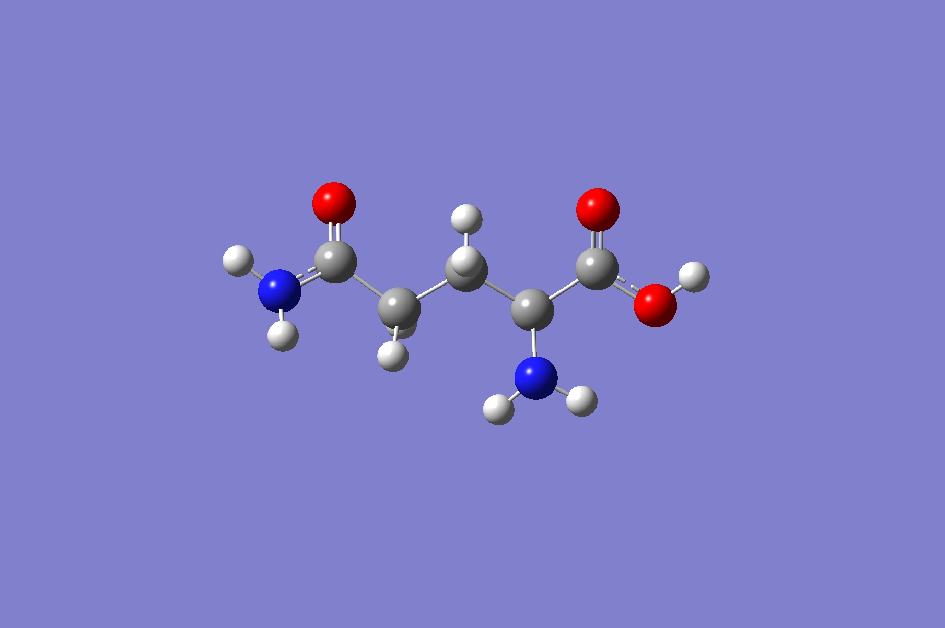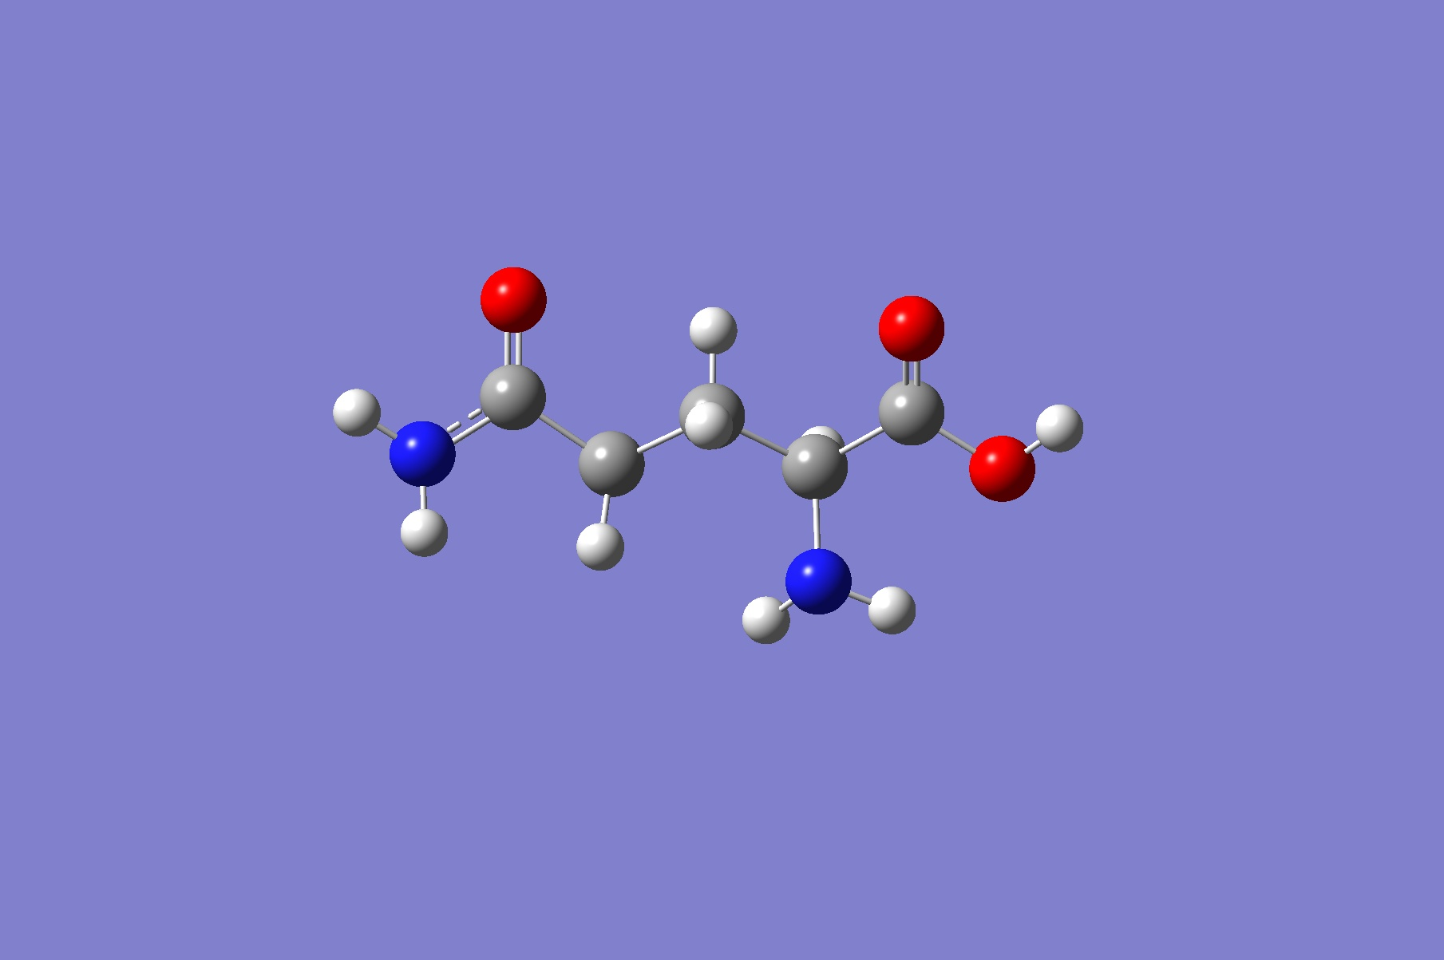

Figure 1-a: optimized geometry with HF

Figure 1-b: optimized geometry with B3LYP

* **Interaction with Water**

In order to be able to calculate interaction with a water molecule and not fall into basis set superposition error supermolecule approach is used where for initial step H of water molecule is bonded with O of the carboxyl group (Figure 2-a) and as second step water is placed at a distance significantly further than bonded state (figure 2-b). Having same number of basis sets, energy difference in both steps is calculated to get the interaction energy.

**Results**

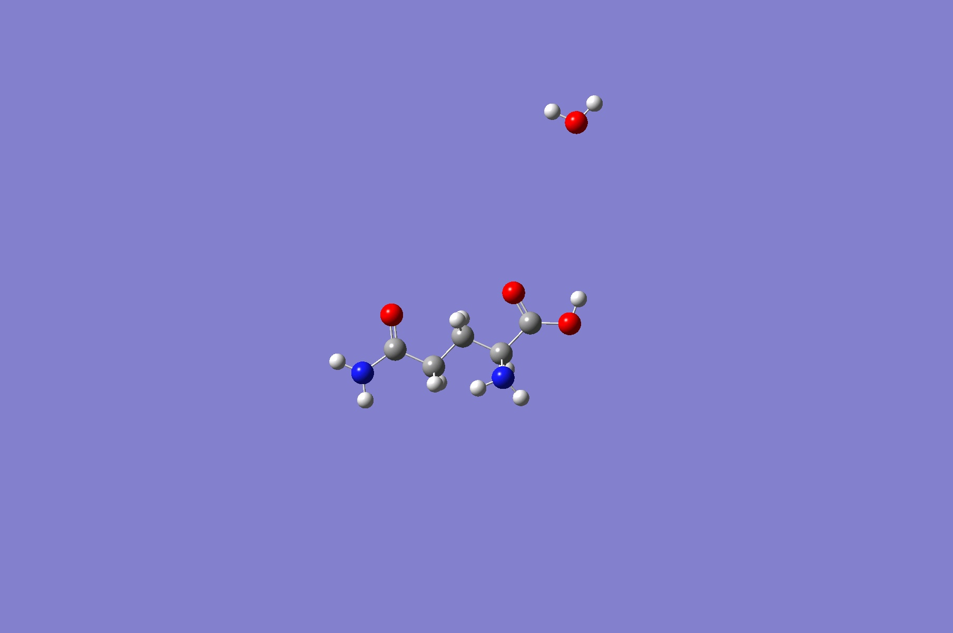

Figure 2-b: Non -interacting water and glutamine molecules

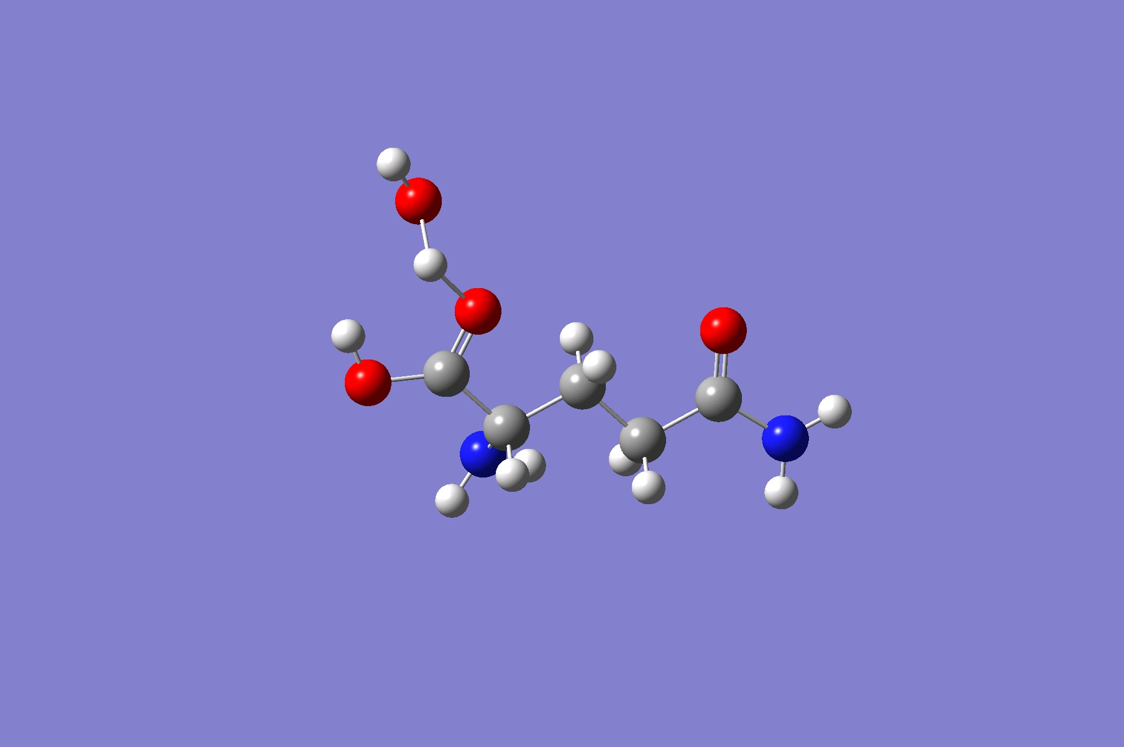

Figure 2-a: Supermolecule of water and glutamine

Table 1-a: Mulliken charges of HF method

Table 1-b: Mulliken charges of B3LYP method

|  |  |  |  |  |  |  |
| --- | --- | --- | --- | --- | --- | --- |
| ID |  | Charge |  | ID |  | Charge |
| 1 | C | 0.753177 |  | 11 | H | 0.1786 |
| 2 | N | -0.952478 |  | 12 | C | 0.818274 |
| 3 | O | -0.597093 |  | 13 | N | -0.848277 |
| 4 | C | -0.452706 |  | 14 | O | -0.5717 |
| 5 | H | 0.177992 |  | 15 | O | -0.752914 |
| 6 | H | 0.197201 |  | 16 | H | 0.4046 |
| 7 | C | -0.272217 |  | 17 | H | 0.382097 |
| 8 | H | 0.229364 |  | 18 | H | 0.477366 |
| 9 | H | 0.221376 |  | 19 | H | 0.358728 |
| 10 | C | -0.100812 |  | 20 | H | 0.349422 |

|  |  |  |  |  |  |  |
| --- | --- | --- | --- | --- | --- | --- |
| ID |  | Charge |  | ID |  | Charge |
| 1 | C | 0.582129 |  | 11 | H | 0.140004 |
| 2 | N | -0.774164 |  | 12 | C | 0.614539 |
| 3 | O | -0.48357 |  | 13 | N | -0.728626 |
| 4 | C | -0.397699 |  | 14 | O | -0.450684 |
| 5 | H | 0.155476 |  | 15 | O | -0.605391 |
| 6 | H | 0.167099 |  | 16 | H | 0.347217 |
| 7 | C | -0.225064 |  | 17 | H | 0.329086 |
| 8 | H | 0.189828 |  | 18 | H | 0.418651 |
| 9 | H | 0.181906 |  | 19 | H | 0.311165 |
| 10 | C | -0.080392 |  | 20 | H | 0.308491 |

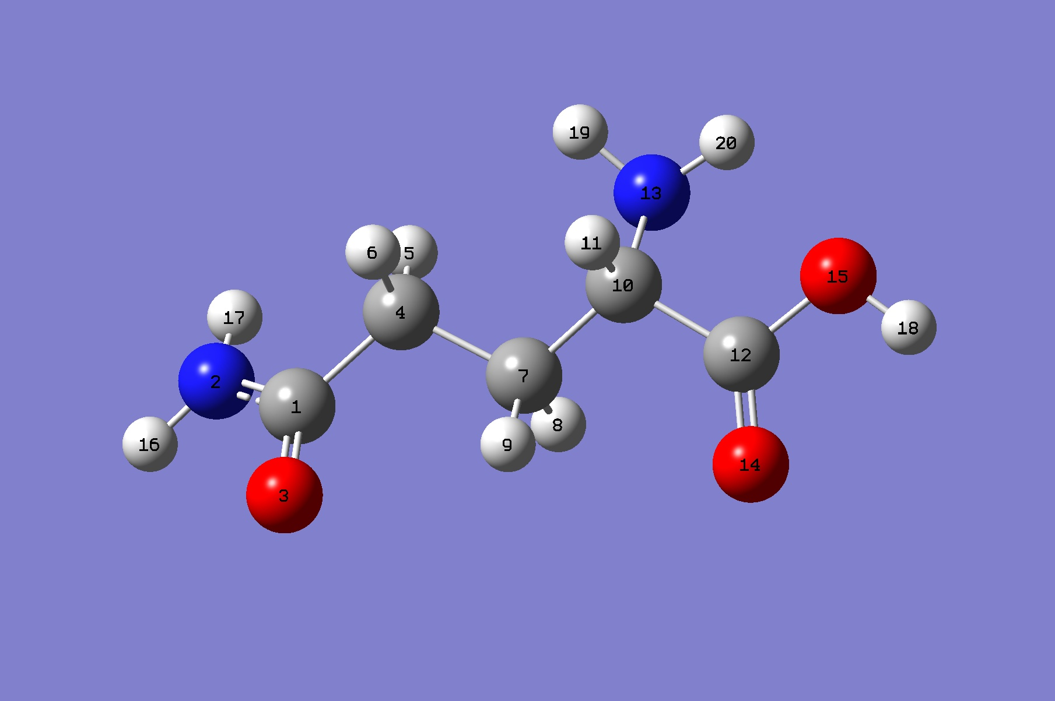

Figure 3: ID’s of atoms on glutamine

Looking at obtained Mulliken charges on corresponding ID’s of atoms (Table 1, Figure 3) for both methods we can see that even though values are in same magnitude and they have the same sign, differences are significant and sometimes greater than 20% meaning these methods cannot be used for comparison amongst each other.

Important geometrical parameters of an amino acid are acid and amine groups. Highest charge values are located on these groups meaning they are the most active groups in a reaction. In fact, since for both methods charge on carbon ID:12 is bigger than carbon ID:1 and charge on N of the amine group (ID:2) is more negative than charge on O of the –OH group (ID:15), self-polymerization of amino acids to form polyamides can be justified.

Comparing frequency, apart from the mode with lowest frequency value HF always gives higher frequency than B3LYP method (Table 2). This is most likely caused by the fact that HF overestimates energy due the fact that it ignores electronic correlation. B3LYP is not susceptible to such error as it is a part of completely different approach (DFT) which to some degree takes into account the electron correlation energy.

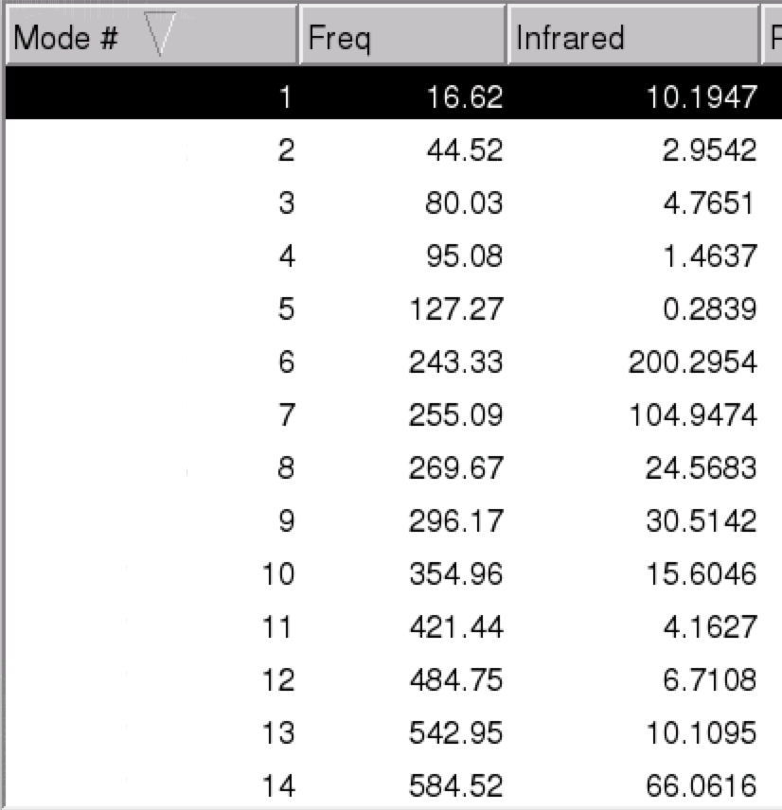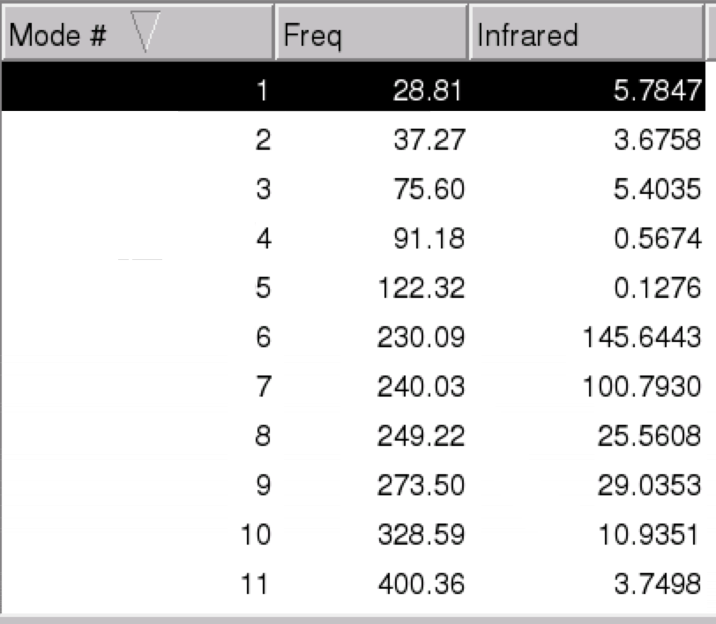

Table 2-b: Portion of frequency values for B3LYP method

Table 2-a: Portion of frequency values for HF method

For interaction of water with glutamine, H of OH (ID:18) and O of H2O is selected as a candidate site for supermolecule approach (Figure 4).

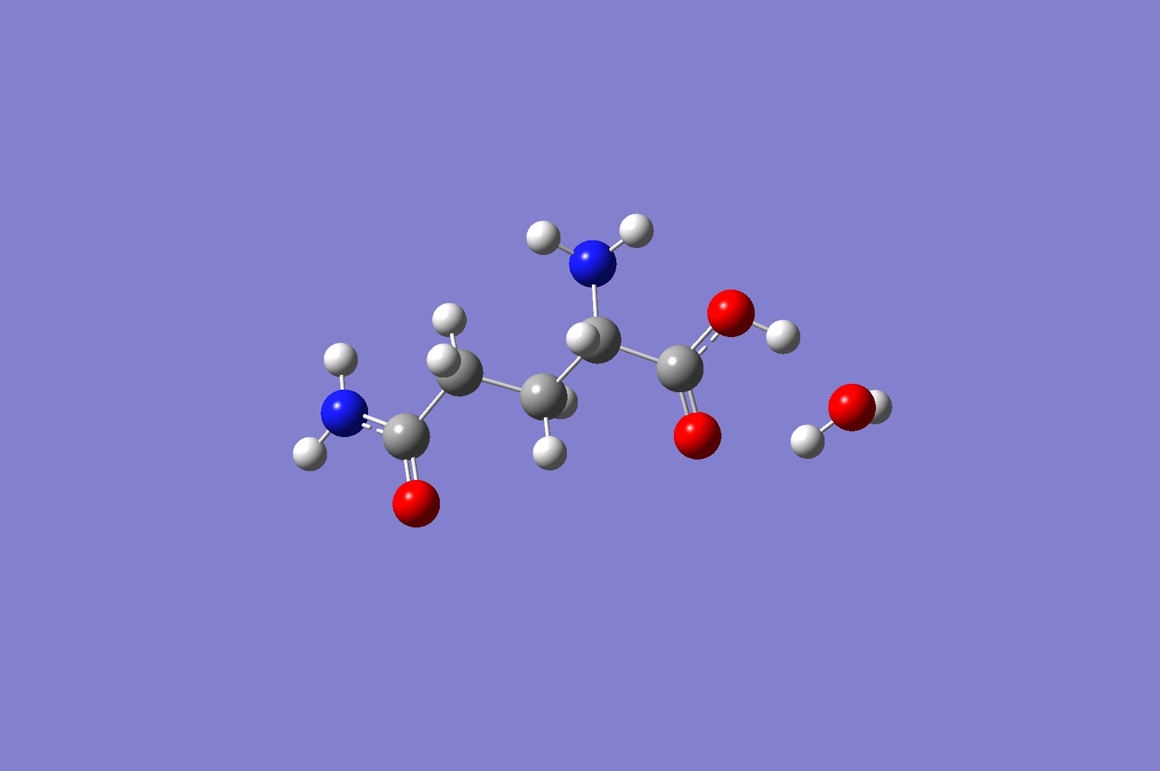

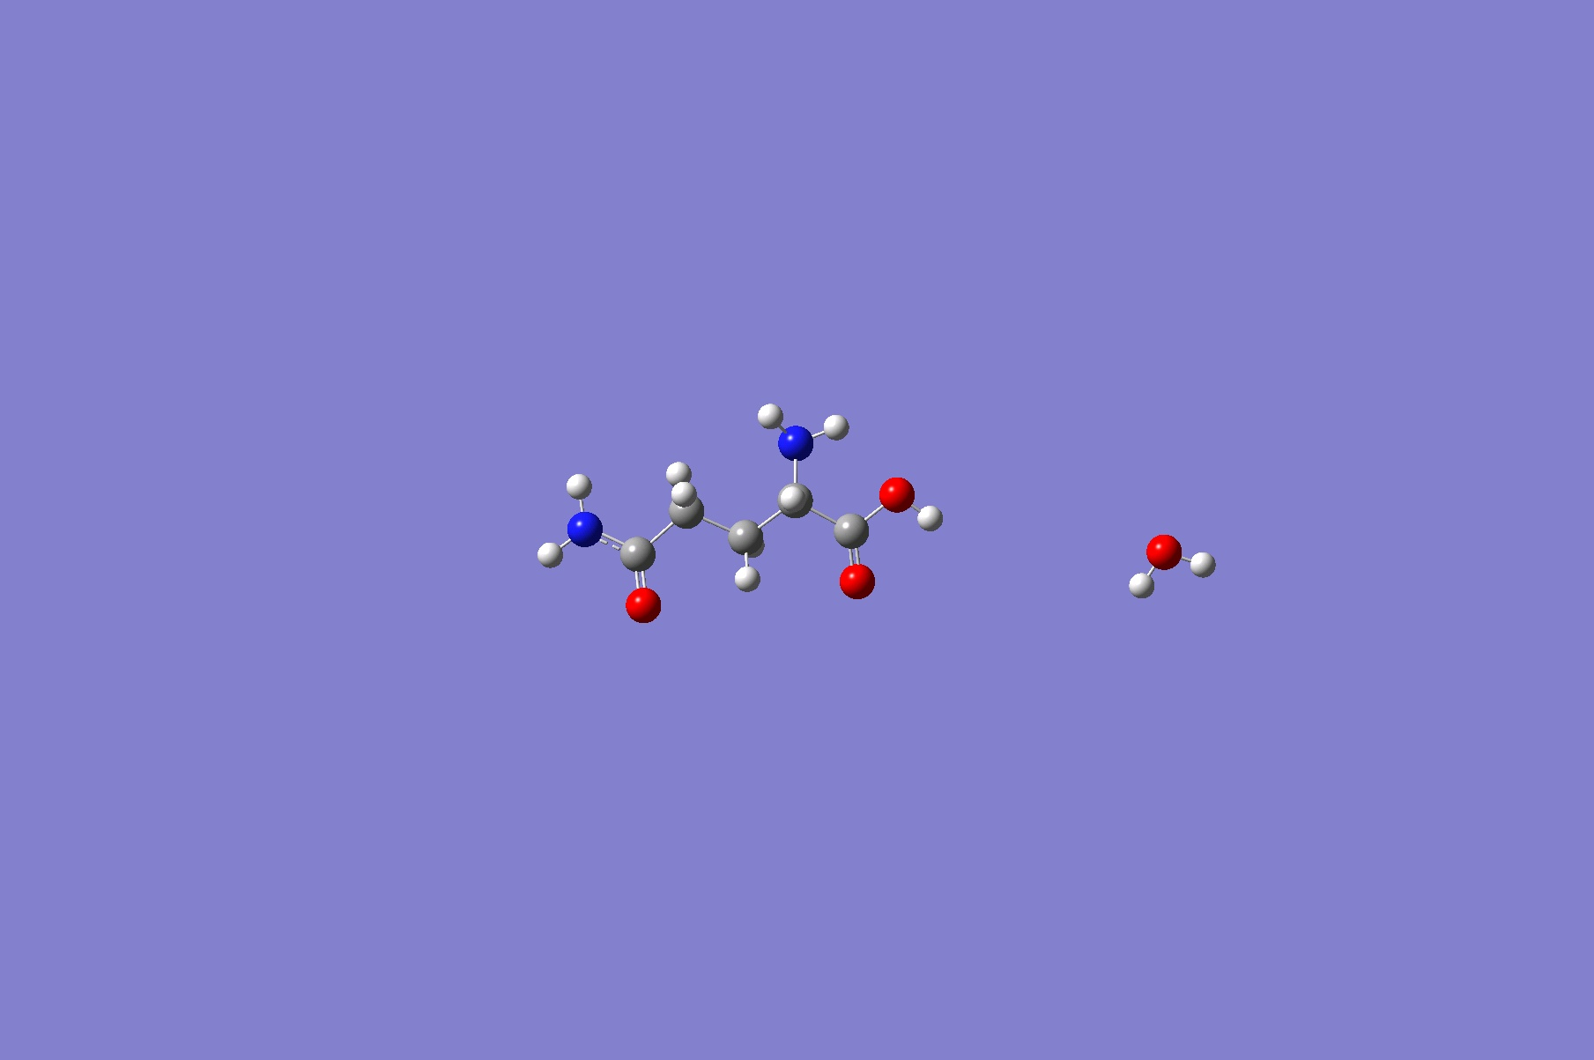

Figure 4-a: Interacting water and glutamine molecule

Figure 4-b: Non - interacting (low interacting) water and glutamine molecule

Energy values: Bonded: -608.1778 au Non-bonded: -608.1532 au

Difference: -0.0246 Hartrees or -64.587305 kj/mol which should be within reasonable range of interaction energy of water with glutamine.